**Cisco Packet Tracer Interface**

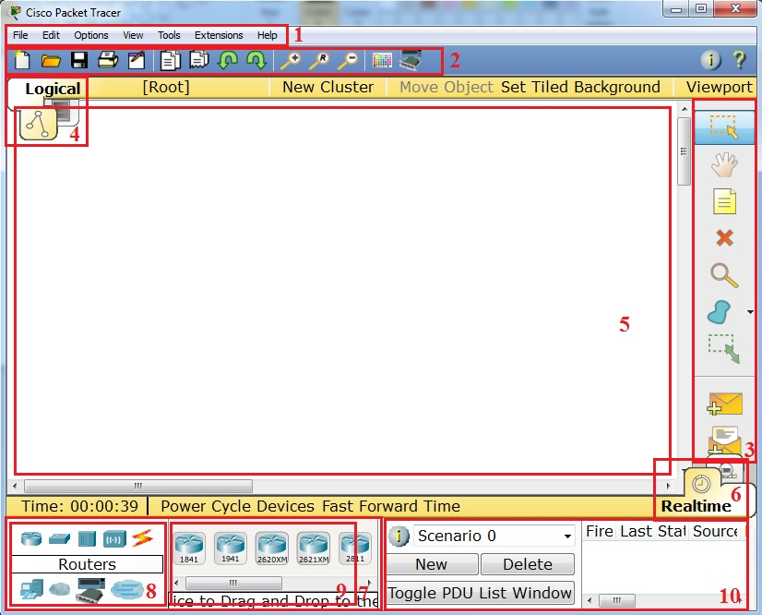

|  |  |  |
| --- | --- | --- |
| 1 | **Menu Bar** | This bar provides the **File, Edit, Options, View, Tools, Extensions**, and **Help** menus. You will find basic commands such as **Open, Save, Save as Pkz**, **Print**, and **Preferences** in these menus. You will also be able to access the **Activity** **Wizard** from the **Extensions** menu. |
| 2 | **Main Tool Bar** | This bar provides shortcut icons to the **File** and **Edit** menu commands. This bar also provides buttons for **Copy**, **Paste**, **Undo**, **Redo**, **Zoom**, the **Drawing Palette**, and the **Custom Devices Dialog**. On the right, you will also find the **Network Information** button, which you can use to enter a description for the current network (or any text you wish to include). |
| 3 | **Common Tools Bar** | This bar provides access to these commonly used workspace tools: **Select**, **Move Layout**, **Place Note**, **Delete**, **Inspect**, **Resize Shape**, **Add Simple PDU**, and **Add Complex PDU**. See “Workspace Basics” for more information. |
| 4 | **Logical/Physical Workspace and Navigation Bar** | You can toggle between the Physical Workspace and the Logical Workspace with the tabs on this bar. In Logical Workspace, this bar also allows you to go back to a previous level in a cluster, create a **New Cluster**, **Move Object**, **Set Tiled Background**, and **Viewport**. In Physical Workspace, this bar allows you to navigate through physical locations, create a **New City**, create a **New Building**, create a **New Closet**, **Move Object**, apply a **Grid** to the background, **Set Background**, and go to the **Working Closet**. |
| 5 | **Workspace** | This area is where you will create your network, watch simulations, and view many kinds of information and statistics. |
| 6 | **Realtime/Simulation Bar** | You can toggle between Realtime Mode and Simulation Mode with the tabs on this bar. This bar also provides buttons to **Power Cycle Devices** and **Fast Forward Time** as well as the **Play Control** buttons and the **Event List** toggle button in Simulation Mode. Also, it contains a clock that displays the relative **Time** in Realtime Mode and Simulation Mode. |
| 7 | **Network Component Box** | This box is where you choose devices and connections to put into the workspace. It contains the **Device-Type Selection** Box and the **Device-Specific Selection** Box. |
| 8 | **Device-Type Selection Box** | This box contains the type of devices and connections available in Packet Tracer. The **Device-Specific Selection** Box will change depending on which type of device you choose. |
| 9 | **Device-Specific Selection Box** | This box is where you choose specifically which devices you want to put in your network and which connections to make. |
| 10 | **User Created Packet Window\*** | This window manages the packets you put in the network during simulation scenarios. See the “Simulation Mode” section for more details. |

**User Modes in Cisco Packet Tracer**

What is the difference between user mode and privileged mode?

User EXEC level allows you to access only basic monitoring commands; privileged EXEC level allows you to access all router commands. Privileged EXEC level can be password protected to allow only authorized users the ability to configure or manage the router.

|  |  |  |  |
| --- | --- | --- | --- |
| **Mode** | **Symbol** | **How to access this mode** | **Command for leaving this mode** |
| User EXEC Mode | Router > | Default mode after booting. Press enter for accessing this. | Use **exit** command |
| Privileged EXEC mode | Router # | Use **enable** command from user exec mode for entering into this mode | exit |
| Global Configuration mode | Router(config)# | Use **configure terminal**command from privileged exec mode | Exit or Ctrl+Z for user EXEC mode |
| Interface Configuration | Router(config-if)# | Use **interface <interface name+number>**command from global configuration mode | Use **exit** command to return in global mode |

**How to Change the Cisco Switch or Router name**

You can change the cisco router name by using command **hostname** in global configuration mode.

[change-router-name](https://www.w7cloud.com/wp-content/uploads/2016/10/Change-router-name.jpg)

Configure password encryption.

**Router(config)# service password-encryption**

**How to set the Enable password:**

You can set the password for protecting enable mode by following command: (Following command will set the password to cisco)

[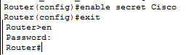](https://www.w7cloud.com/wp-content/uploads/2016/10/Enable-password-cisco.jpg)

Erase the startup configuration file from NVRAM.

**Router# erase startup-config**

Reload the router to remove an old configuration from memory.

**Router# reload**

**How to save the configurations:**

You can use the following command for router configuration to Nvram for use at next boot up

Router#**copy running-config startup-config**

**How to set the IP address to Cisco interface:**

You can set the IP address to any Cisco device interface by using the following commands:

Router(config)#interface <interface name & number>

Router(config-if)#ip address <IP address> <subnet mask>

***How to enable a port or interface***

Router(config-if)#no shut

**How to create a static route on Cisco router**

Router(config-router)#**ip route [destination_network] [mask] [next-hop_address]**

Router(config-router)#**ip route 192.132.23.1 255.255.255.0 10.10.10.1**

**How to configure the default route on Cisco:**

Following command will set the default route to 10.10.10.101.

Router(config)# ip route 0.0.0.0 0.0.0.0 10.10.10.101

### Famous Show Commands in Privileged EXEC Mode

You can run all these command for checking different setting of Cisco device in privileged EXEC mode:

**Show version**

**Show running-config**

**Show interface <interface name>**  
**show ip route**

**Show Vlan**

**Show protocols**

**Show startup-config**

**………..**

**And more**